**Problem C - Jocas really likes shooting balls!**

**Description**

Jocas has been so successful with the game of the last week that the company asked to do another one. And, of course, in a couple of days, he came out with another very interesting game!

The game works as follows: Given a sequence of balls of different colors, the goal is to eliminate balls by shooting those that are adjacent to others with the same color. (humm, it seems that you already have played this game long time ago but in a 2D version...?)

Whenever the player shoots a ball, all adjacent balls with the same color are eliminated. Everytime the player eliminates more *n > 1* balls with the same color in a single shot, the score increments by *n (n + 1)*. Moreover, the player cannot shoot isolated balls (i.e., no adjacent ball has the same color). Therefore, the game terminates once all balls are shot or there are only isolated balls.

Of course, the order in which the player shoots the balls may lead to different scores as shown in the following example:

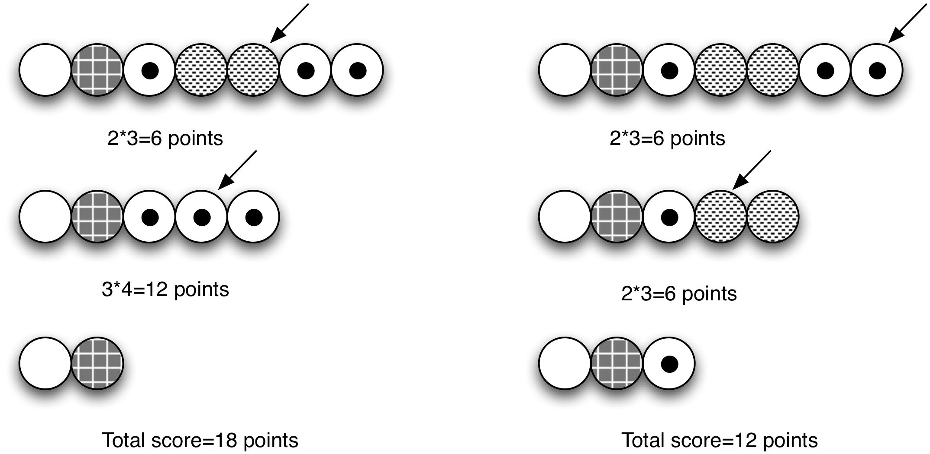

Therefore, the underlying goal of the game is to maximize the score. Could you help Jocas to write a program that gives the largest score that is possible to obtain?

**Task**

Given a sequence of balls, make a program that will determine the largest score that is possible to obtain.

**Input**

The first line contains the number of test cases (*t*) in the same file. Information about the test cases follows in the following *2t* lines. Each test case is described by 2 lines: the first contains the number of balls (*n*) and the sequence of *n* integers, each corresponding to the color of each ball.

**Output**

For each test case, print the largest score.

**Constraints**

* *n ≤ 50*

**Example**

**Example input:**

2

5

1 2 1 2 1

7

1 2 3 4 4 3 3

**Example output:**

0

18